Practical 4

Aim: network vulnerability using Wireshark..

Open windows system and go to Wireshark application.

Use different functions like capture, filter and inspection of packets.

1. Capture

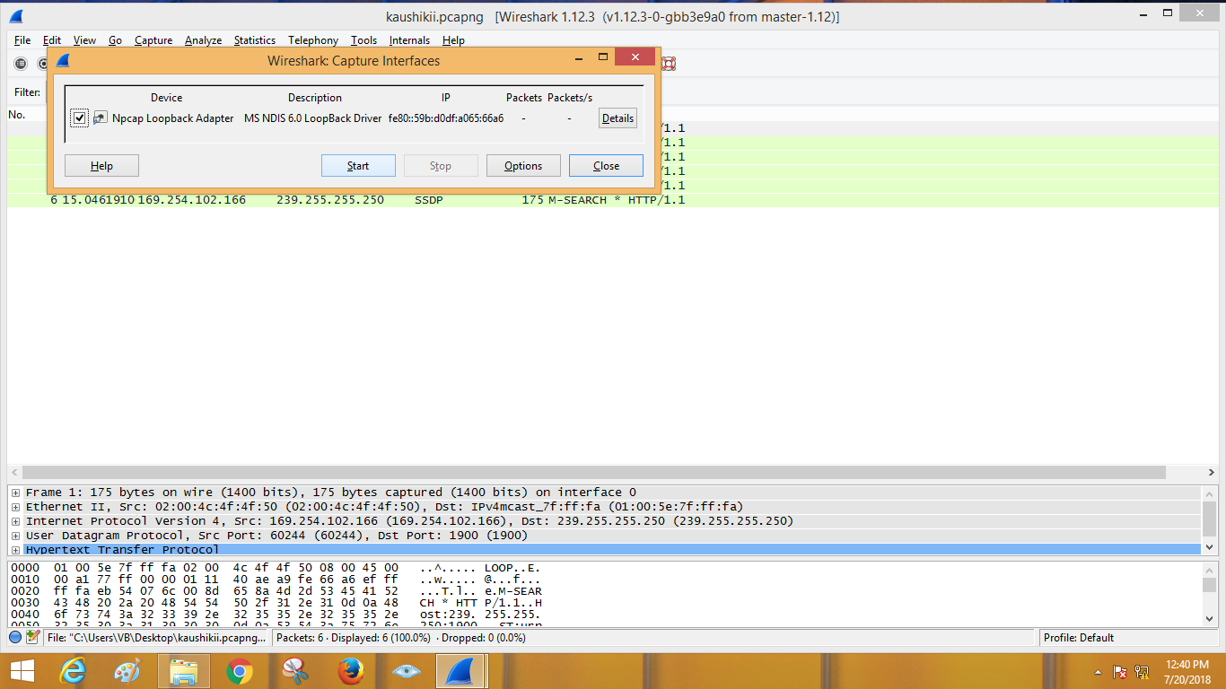

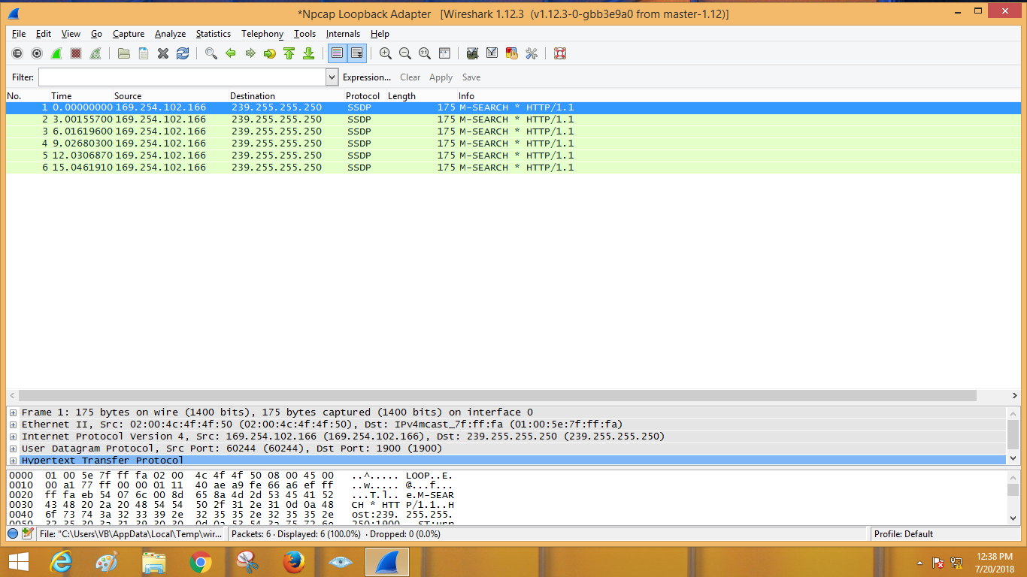

2. Satisticflowgraph

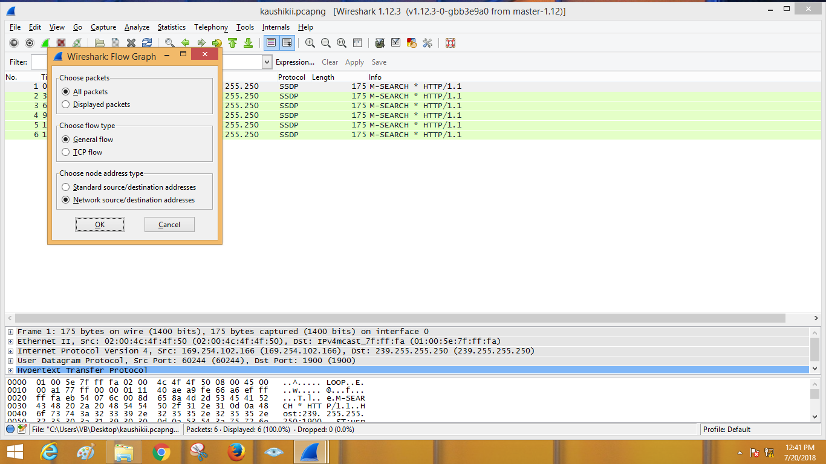

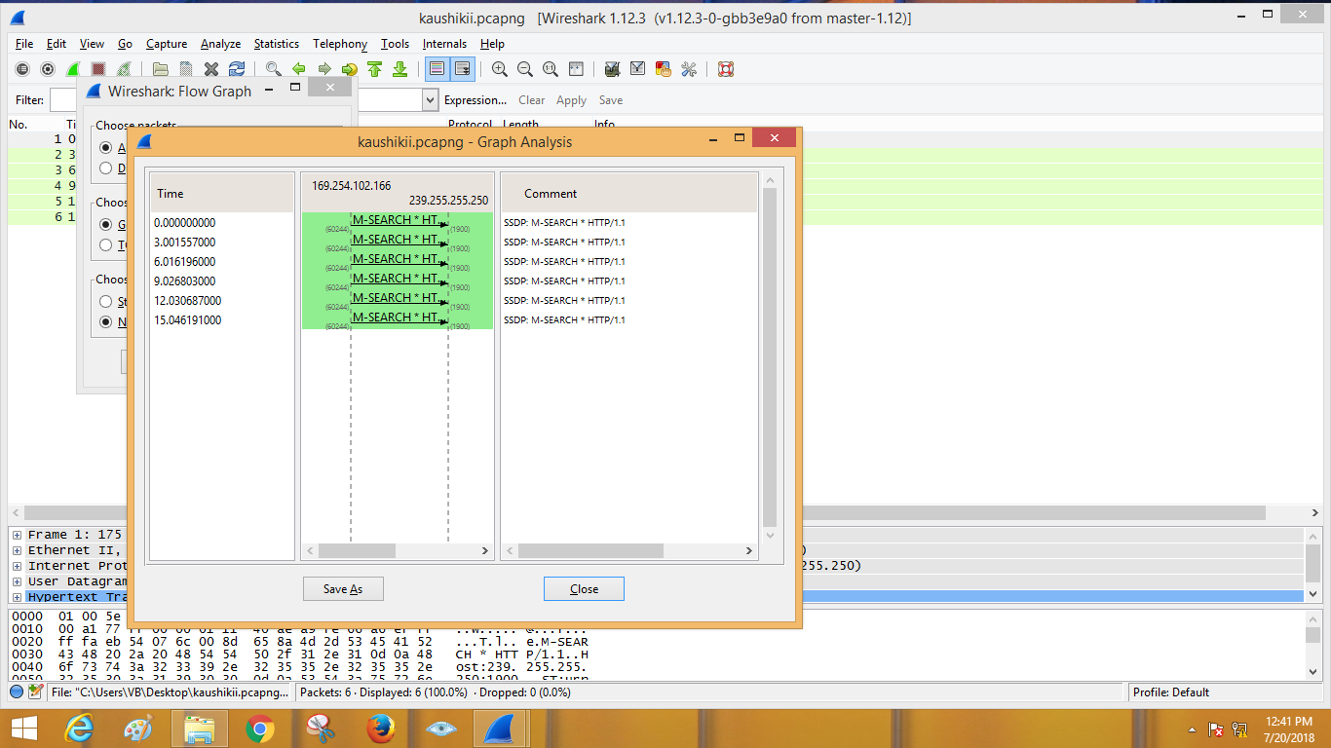

3. Packet inspection.

